2023 Don Burgess
(Boys & Girls) Basketball Camps
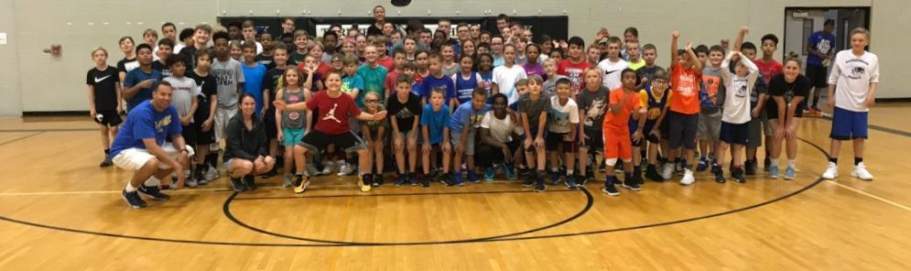

June 12 – 16, 2023 AGES 6 yrs. – 15 yrs.
(9 am – NOON) @ Harrisonburg HS

- Includes Daily Instruction, lots of FUN & Camp T-shirt
- Daily Contests, 3 on 3 games and 5 on 5 games
- Grouped according to Age, Size, and Ability * Camper to Staff Ratio of 9 : 1
- AGE GROUPS: 6 / 7 yrs old 8/9 yrs old 10/ 11 yrs old 12 & up
- LIMITED SPACES for each age group
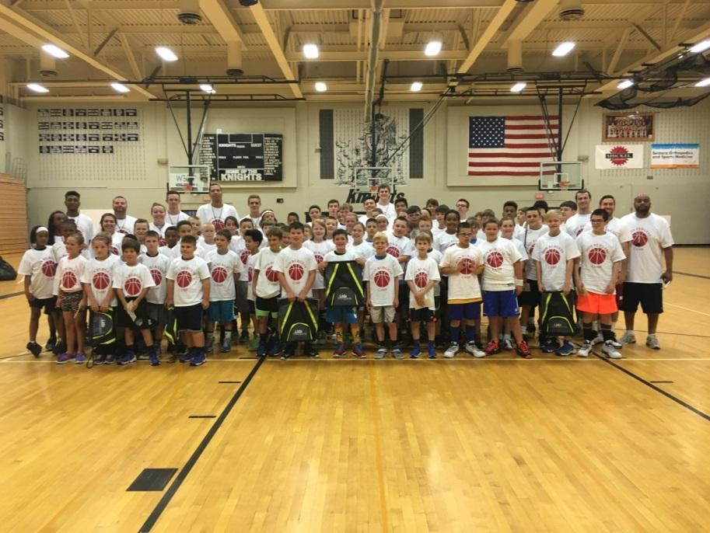 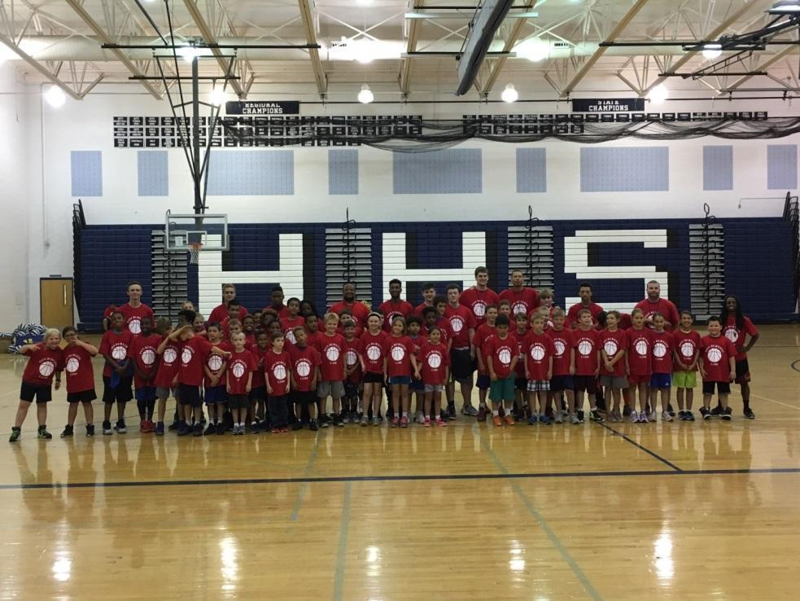 “I have over 25+ years of experience with directing summer basketball camps & coaching at the Collegiate & High School level. My camp staff & I will provide individual teaching & skill development in a fun and positive environment. I want your son/daughter to have a positive and enjoyable learning experience.”
Don Burgess, Camp Director
If you have any questions please contact 540-246-8170 or burgessbasketballcamp@yahoo.com
*DISCOUNT*
Register by MAY 1st
$20 OFF of FULL DAY
$10 OFF of HALF DAY
www.donburgessbasketballcamp.com

